**Assignment**: (Spring MVC) - Assignment ID: 10_Spring_Assignment4

Develop Web application to facilitate the below operations using Spring Web MVC Integrating with Spring Data and add search book by title and search subject by duration operations using custom queries

a. Add a Book

b. Delete a Subject

c. Delete a book

d. Search for a book

e. Search for a subject

**Code**:



**Web Page Screenshots (Angular and Webservice - Spring Data)**:

**Subject Book List**

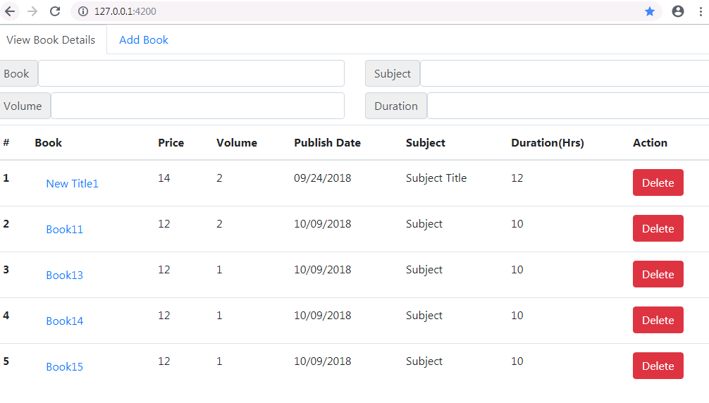

**Subject Book Add Page**

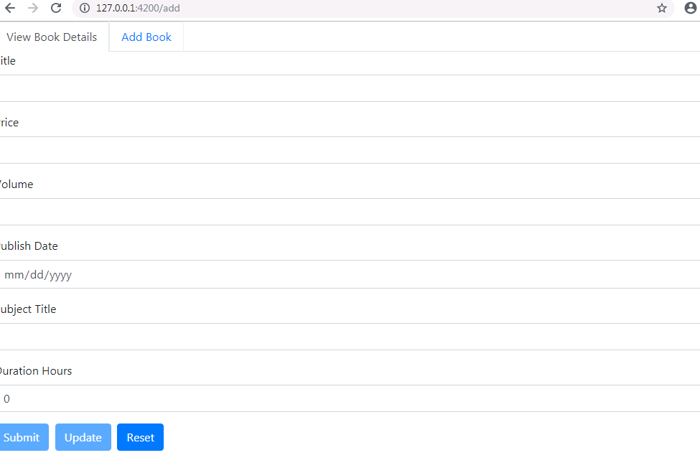

**Search using Book**

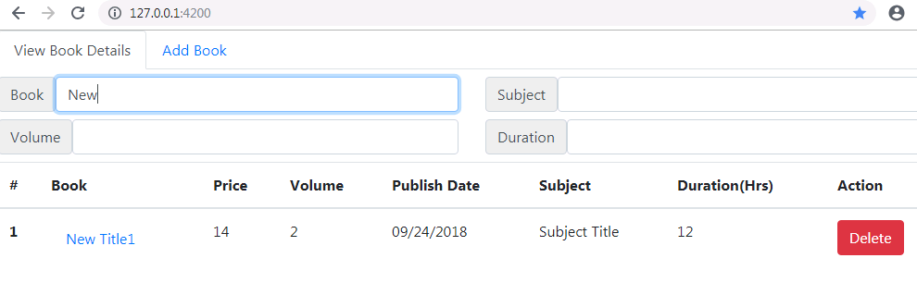

**Search using Subject**

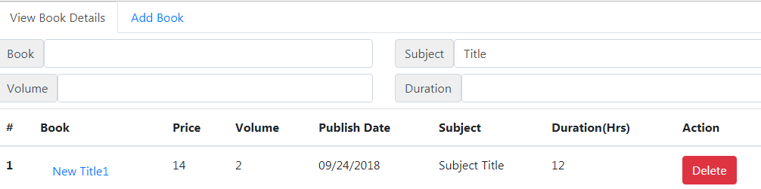

**Search using Volume**

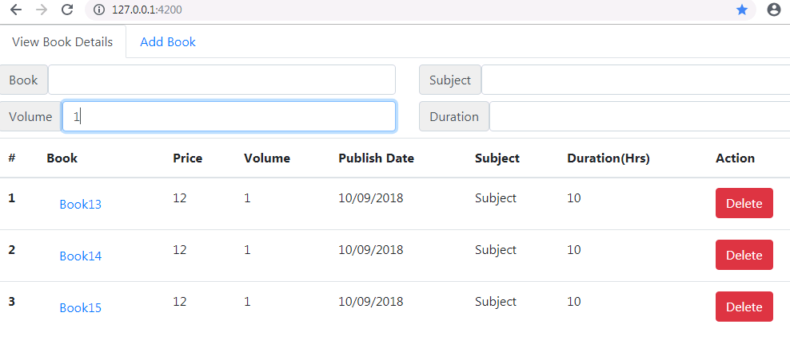

**Mongo DB Command prompt**

